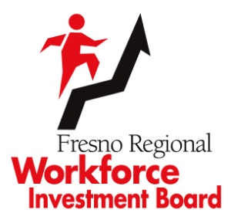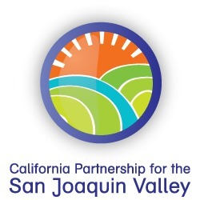

Date

Dear Hiring Manager:

As your local Employment Referral Partner, the Fresno Regional Workforce Investment Board’s Workforce Connection is dedicated to providing your business with cost-effective ways to successfully recruit job applicants in order to meet your business needs. Our services are at no cost to your business, thereby saving you valuable time and money.

This job applicant is being referred by the Workforce Connection for your consideration for employment upon earning our WorkKeys® Central California Work Readiness Certificate after his/her successful completion of our in-depth skills evaluation and employment readiness process.

WorkKeys® Foundational Skills assessments measure cognitive abilities such as applied mathematics, reading for information, and locating information. Assessments in these areas help job seekers measure their skill levels against those skills required by the workplace. Feel free to ask the applicant for the occupational printout of the job for which we are referring him/her, or to view how his/her WorkKeys® scores compare to the WorkKeys® score averages across different occupations, log on to www.wincareers.com and enter:

- Username: Wincareers
- Password: CACA
- Login
- Career Alignment: select DOT, ONET or both
- Qualifications: insert the scores under the categories of Applied Mathematics, Locating Information, and Reading for Information
- Select all qualified: this shows all the jobs the applicant has the skill and competency to learn

Additional on-the-job training may be required to provide the applicant the necessary technical skills you require.

We hope that you will find that our referral of this candidate will assist you in your recruitment efforts. Thank you for allowing us this opportunity to present job applicants from our organization.

