EMPLOYERS!  Connect With Qualified Candidates  Through  On-the-Job Training Opportunities |  | 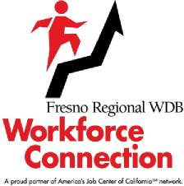

On-the-Job Training (OJT) opportunities are available to employers interested in providing training that will lead to full-time employment for qualified job seekers.
Approved Employers will have the confidence of knowing that job applicants referred by Workforce Connection for their consideration for an OJT have successfully completed an in-depth skills evaluation and employment readiness process. We will work together to determine what types of employer services you may be eligible to receive.
The Benefits of an OJT:
- Employers are reimbursed a percentage of the wage rate for the duration of the training contract of an OJT to offset the additional short-term costs of providing training and supervision to the OJT applicant.
- Employers confirm the ability to pay the full wage amount upon completion of the OJT with the intention to retain the applicant as a full-time, regular employee.
You have nothing to lose but everything to gain!
Let me help you with your hiring needs.
Call: Insert TMS Name
(559) xxx-xxxx

email@workforce-connection.com
Funded by the Fresno Regional Workforce Development Board (FRWDB). The FRWDB is an equal opportunity program. Auxiliary aids and services are available by request to individuals with disabilities and/or limited English.
Rev 09/2019 Workforce Connection OJT

