Instructions to
Create an Account
and use IMAGO for the Interview Preparation Workshop
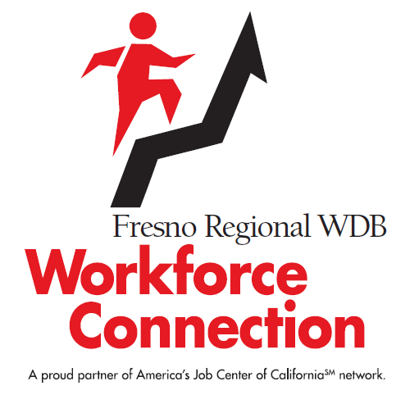

There are currently two Workshop series we offer at Workforce Connection using the IMAGO website. The first is the Job Readiness Workshop and the second is the Interview Prep Workshop. Below are the instructions to create an account and to log-in for any classes that will be assigned to you.
This is the link to the log-in page:
https://go.weareimago.com/login

- First Time Users – Account Creation

The first time you use the site you will create an account with a log-in & password. There are a couple of ways you can do this do this:

- Click on the link below to view a short video:
https://cdn.weareimago.com/study_material/attachments/43356/How_to_Add_Learners.mp4?1586988553

- Refer to the directions included as an attachment in your email titled: FresnoWorkforceIMAGOAccountCreation

If neither of the methods above work, you may contact a Workshop Facilitator:

Name: ___________________________
Phone: __________________________
Email: ___________________________

You may find using the Chrome Web Browser will help with a successful experience.

- Enrollment Key

While you are creating an Account, you will be prompted to enter an Enrollment Key.

Here is the Enrollment Key (it is case sensitive):
T97RKQAU

- Instructor’s email

Once you are logged in and ready to add your class (+Add Class in the upper right corner), there will be a prompt to “Search Instructors Email”

Here is the email you will use:
______________________
Select the class Your Interview Story. The class will be available to you and you will see small boxes displaying each lesson by name.
- Interview Preparation Workshop Pre-work
The first lesson you will select after adding the class as described above will be “Your Interview Story”.
Before you can begin the Workshop, you will need to complete the “Guide Only” for “Your Interview Story”. Once this has been submitted to the Facilitator through the IMAGO site, you will be able to attend the workshop.

When the “Guide Only” is opened you will answer all the questions (you may have to enter them in sequence). ***What you put into these lessons is what you will get out of them, so give yourself your best!***

If you are not able to complete them quickly (so you don’t time out) or all at one time you may “Save” (upper left corner) and “Exit” (X in the upper right corner) and come back later to finish where you left off. When you are done with the entire lesson “Submit” (Upper left corner) the lesson. “Save” just saves your progress. Your lesson is not complete until you “Submit” it
- Day 1 of the Interview Preparation Workshop and Assignments

During Day 1 of the Interview Prep Workshop you will join the Workshop (at the scheduled time) by clicking on the email Webex “Join” link provided by your Facilitator. During the workshop you will have discussion and view a series of videos relating to the Do’s & Don’ts of commonly asked interview questions. After class you will complete Study Guides and “Submit” them to get credit for attending the workshop (We also hope this will help you prepare to be an interview super star!)

Here is the list of lessons in sequence for the assignments you will complete after class on the 1st day:
- Tell Me About Yourself - Your Answers
- Why Should We Hire You? - Your Answers
- Why Do you Want To Work Here? - Your Answers
- What Is Your Greatest Weakness? - Your Answers
- Describe A Conflict And Its Resolution - Your Answers

After class you will log in to your IMAGO account and find the lessons assigned to you.

As you open each lesson you will click on the “Guide Only” to enter your answers for each of the questions. You will type in some of your answers and some you will select by clicking on a bubble next to your answer. Once you have completed each study guide you will click on “Submit”. Remember you may “Save” your progress if you are not able to complete the lesson right away.

As you complete each of the lessons and “Submit” the answers on the study guide your instructor will receive your completed lessons.

- Day 2 of the Interview Preparation Workshop

At the scheduled time for Day 2 you will join the Workshop by clicking on the email Webex “Join” link provided by your Facilitator.

During Day 2 the group will work with the Facilitator to share their responses to the commonly asked interview questions. The group will give and receive constructive feedback about their answers. Remember this workshop is provided to help our participants prepare for effective employment interviews. We have found when job seekers are prepared and confident in their ability to communicate the skills and experience related to the jobs they interview for; their interviews go much better! We ask that everyone participate with the intent to be kind, encouraging and helpful to all the workshop attendees.

When the whole series has been completed you will be given a Certificate of Completion for your accomplishment.

We hope this Interview Preparation Workshop will help you prepare for and gain confidence in your interviewing skills. GOOD LUCK!!!

