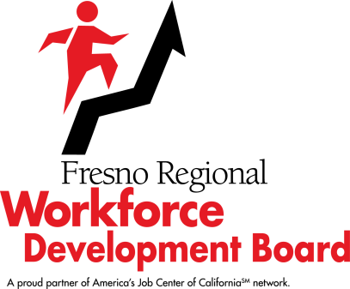

Workforce Development Board
January 20, 2021 @ 4:30 p.m.
SPECIAL MEETING

SUMMARY MINUTES

The meeting was called to order at 4:30 p.m. and was held via Zoom.

ROLL CALL: PRESENT – Paul Bauer, Edgar Blunt, Alysia Bonner, Raine Bumatay, Brian Chambers, Fely Guzman, Jeff Hensley, Mike Karbassi, Dennis Montalbano, Delfino Neira, Joe Olivares, Chuck Riojas, Michael Silveira, Vasili Sotiropulos, Shelly Tarver, Stuart VanHorn, Lydia Zabrycki, and Legal Counsel Ken Price.

ABSENT – Lacy Barnes, Scott Miller, Sherry Neil, Tommie Nellon, Sal Quintero, and Elizabeth Rivinius.

COMMENTS BY FRWDB CHAIR AND/OR EXECUTIVE STAFF: | None.
AGENDA CHANGES:  REMOVAL OF ITEMS OR  EMERGENCY ADDITIONS: | Blake Konczal, Executive Director, Fresno Regional Workforce Development Board, stated that Item 7 would be moved to be presented prior to Item 6.
ABSTENTIONS/ DISCLOSURES OF  POTENTIAL CONFLICTS  OF INTEREST/RECUSALS: | None.
PUBLIC COMMENTS: | None.

Item | Description/Action Taken
7. | Transit and Equity Presentation
 | Tyler Maxwell, City of Fresno District 4 Councilmember, presented a PowerPoint on the Conserve Fresno project, which aims to serve and preserve different aspect of Fresno’s environment, such as air, water, economy and parks, with an end goal to leave Fresno better for the next generation. His presentation focused on the Zero Fare Bus Act, which would eliminate bus fares citywide. Mr. Maxwell reviewed the expected positive outcomes of the Zero Fare Bus Act, which included stimulating the local economy and reducing carbon emissions. He shared ridership statistics and data from other cities across the nation who have a zero-fare policy. He stated that he was not proposing an increase in taxes and said that no new expenses would be incurred and no money would come from the City’s general fund to implement this policy, but that private/public partnerships and other ongoing partnerships, and other options could be considered for funding. He stated that long-term operation is the key to the success of this program.

Director Montalbano asked about time efficiency of riding the bus if there were not a bus stop in front of the rider’s destination. He gave an example of someone taking a bus to work, but then having to walk from the bus stop to the workplace. Councilmember Maxwell and Director Karbassi stated that the zero-fare policy works well in conjunction with other means of transportation such as bike paths, micro-transit, Bus Rapid Transit and the proposed downtown trolley system.

Councilmember Maxwell thanked the FRWDB and Chair Hensley stated that the FRWDB looks forward to continuing the conversation of transit and equity in Fresno.

This was an information item.

6. | New Location for Fresno City and County’s America’s Job Centers of California
Mr. Konczal reported that the FRWDB currently holds a lease at Manchester Mall for the Fresno City and County America’s Job Centers of California (AJCC), the full-service One-Stop location, and that the lease will be expiring in September 2021. In working with the FRWDB’s primary partners, FRWDB staff developed new site and space requirements for the AJCC and based on requirements, is recommending the AJCC be moved to the Winepress Shopping Center located at Shaw and West Avenues. Mr. Konczal reviewed the many benefits of the proposed new location, such as visible signage on Shaw Avenue, ample parking, Fresno Area Transit stop in front of the location, and centrally located between Freeways 41 and 99.

Director Olivares asked if the Youth Program offices would also be moving. Mr. Konczal explained that the provider of youth services has their own lease, so the Youth Program offices moving would be their decision, but that the FRWDB would be agreeable to that.

There were no questions or comments from the public.

 | RIOJAS/KARBASSI – APPROVED THE NEW LOCATION FOR FRESNO CITY AND COUNTY’S AMERICA’S JOB CENTERS OF CALIFORNIA. VOTE: YES – 15; NO – 0 (UNANIMOUS)
The meeting was adjourned at 5:05 p.m.

