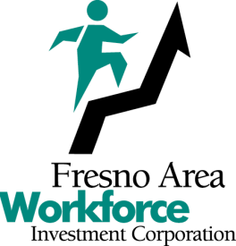

Board of Directors
July 20, 2022

SUMMARY MINUTES

The meeting was called to order at 3:34 p.m.

ROLL CALL: PRESENT - Jeff Hensley, Mike Karbassi, Dennis Montalbano, Chuck Riojas, and Legal Counsel Ken Price

ABSENT - Edgar Blunt, Sal Quintero, and Lydia Zabrycki

AGENDA CHANGES: None

ABSTENTIONS: None

BOARD CHAIR/  STAFF COMMENTS: | None
PUBLIC COMMENTS: None

Item | Description/Action Taken
1. | January 19, 2022, Meeting Minutes
Mr. Konczal presented the January 19, 2022, meeting minutes for approval.

RIOJAS/KARBASSI – APPROVED THE MINUTES OF THE JANUARY 19, 2022, MEETING. (UNANIMOUS)
2. | Fresno Area Workforce Investment Corporation Personnel Manual
Mr. Konczal presented for approval, the updated Fresno Area Workforce Investment Corporation (FAWIC) Personnel Manual. There were six (6) substantive policy changes to the Manual and those changes were outlined in the agenda item. Mr. Konczal noted that the Personnel Manual is reviewed and updated annually by Ken Price, Baker, Manock & Jensen, and Brenda Budke, Sierra HR Partners.
Director Montalbano asked, in reference to Policy 409 that allows FAWIC to obtain verification of an employee’s Driver’s License status, if FAWIC requests proof of automobile insurance from its employees if the employee is required to drive as part of their position with FAWIC. Mr. Konczal and Mr. Price both indicated that the FAWIC does require an employee to provide proof of automobile insurance if driving is a requirement of their position.

RIOJAS/KARBASSI – APPROVED THE FRESNO AREA WORKFORCE INVESTMENT CORPORATION PERSONNEL MANUAL. (UNANIMOUS)
3. | Referral of Agenda Items to the Fresno Regional Workforce Development Board and/or Its Committees
 | There were no items referred to the Fresno Regional Workforce Development Board or its Committees.
4. | October 19, 2022, Agenda Items
 | None.
5. | Meeting Feedback
 | None.
The meeting was adjourned at 3:10 p.m.

